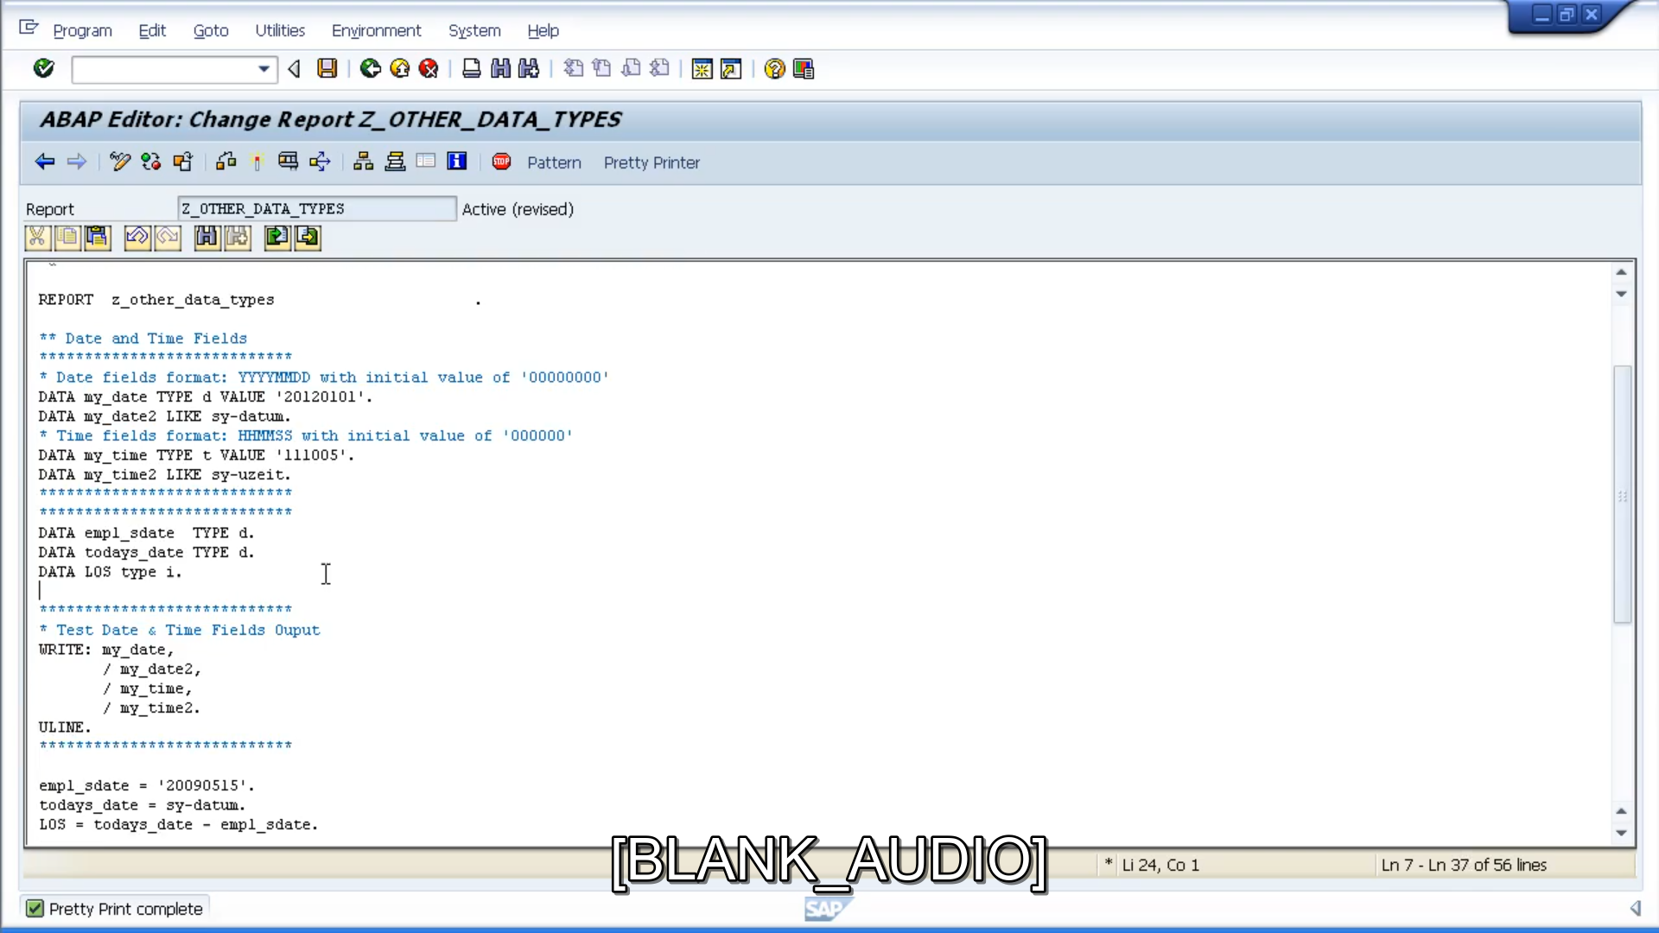

So, the calculation has given us length of service in the number of days.

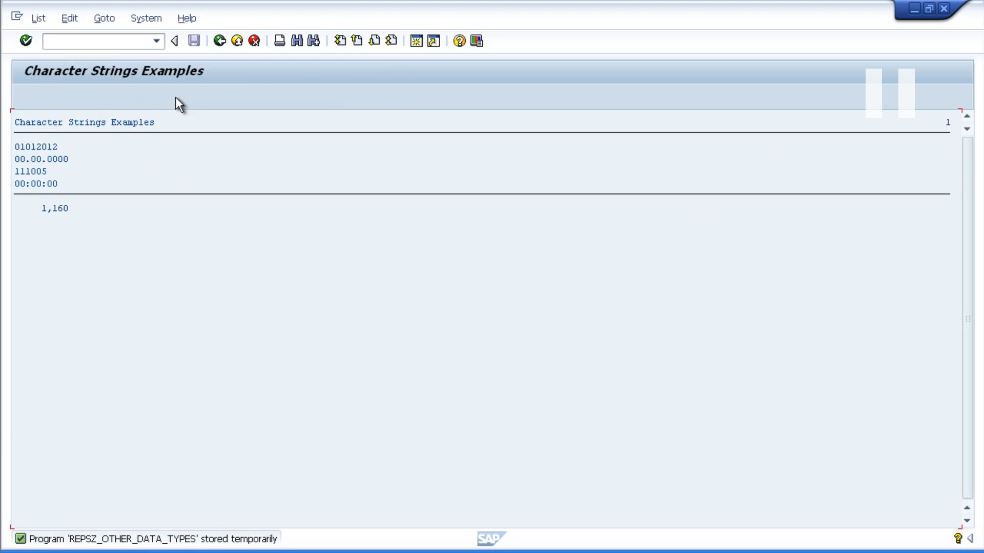

Let's do another example where we want to add 20 days to today's dates. We will use the same today's dates variable, and assign it to the system date again.

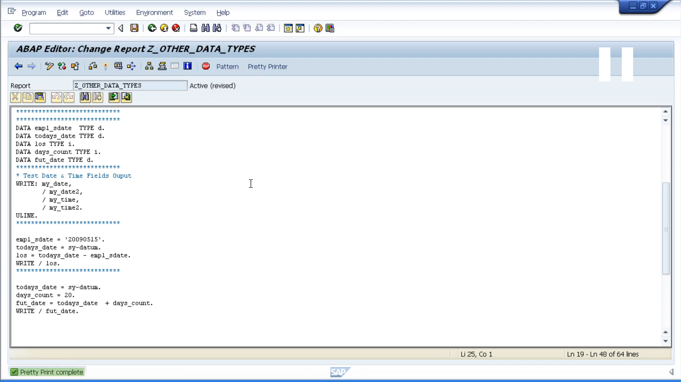

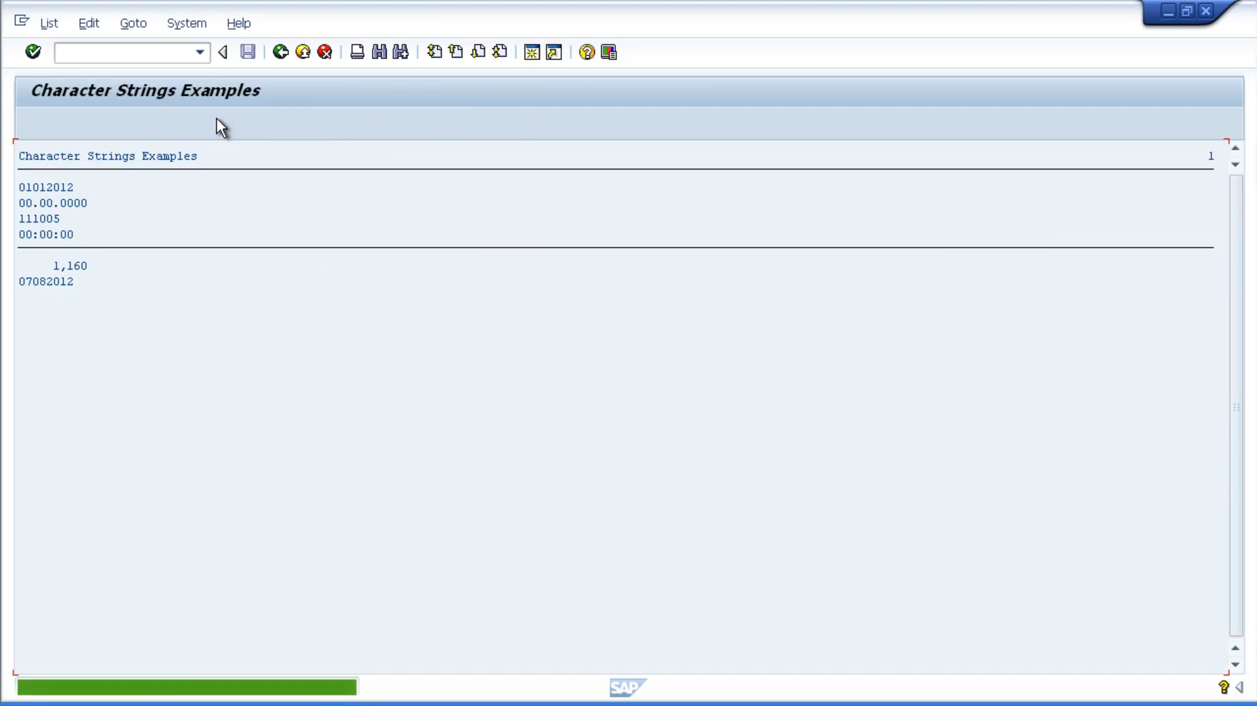

Here we go. So, 20 days on from today, will be the 7th of August, 2012.

If you remember, in a previous module, we worked with sub-fields. Well, all the same logic applies when working with sub-fields that are based on date and time fields. So, let's create an example to change one of our date fields to represent the 20th of the current month. We will leave today's date equalling the system date. What we will do, is make the day sub-field a valid date equal to 20.

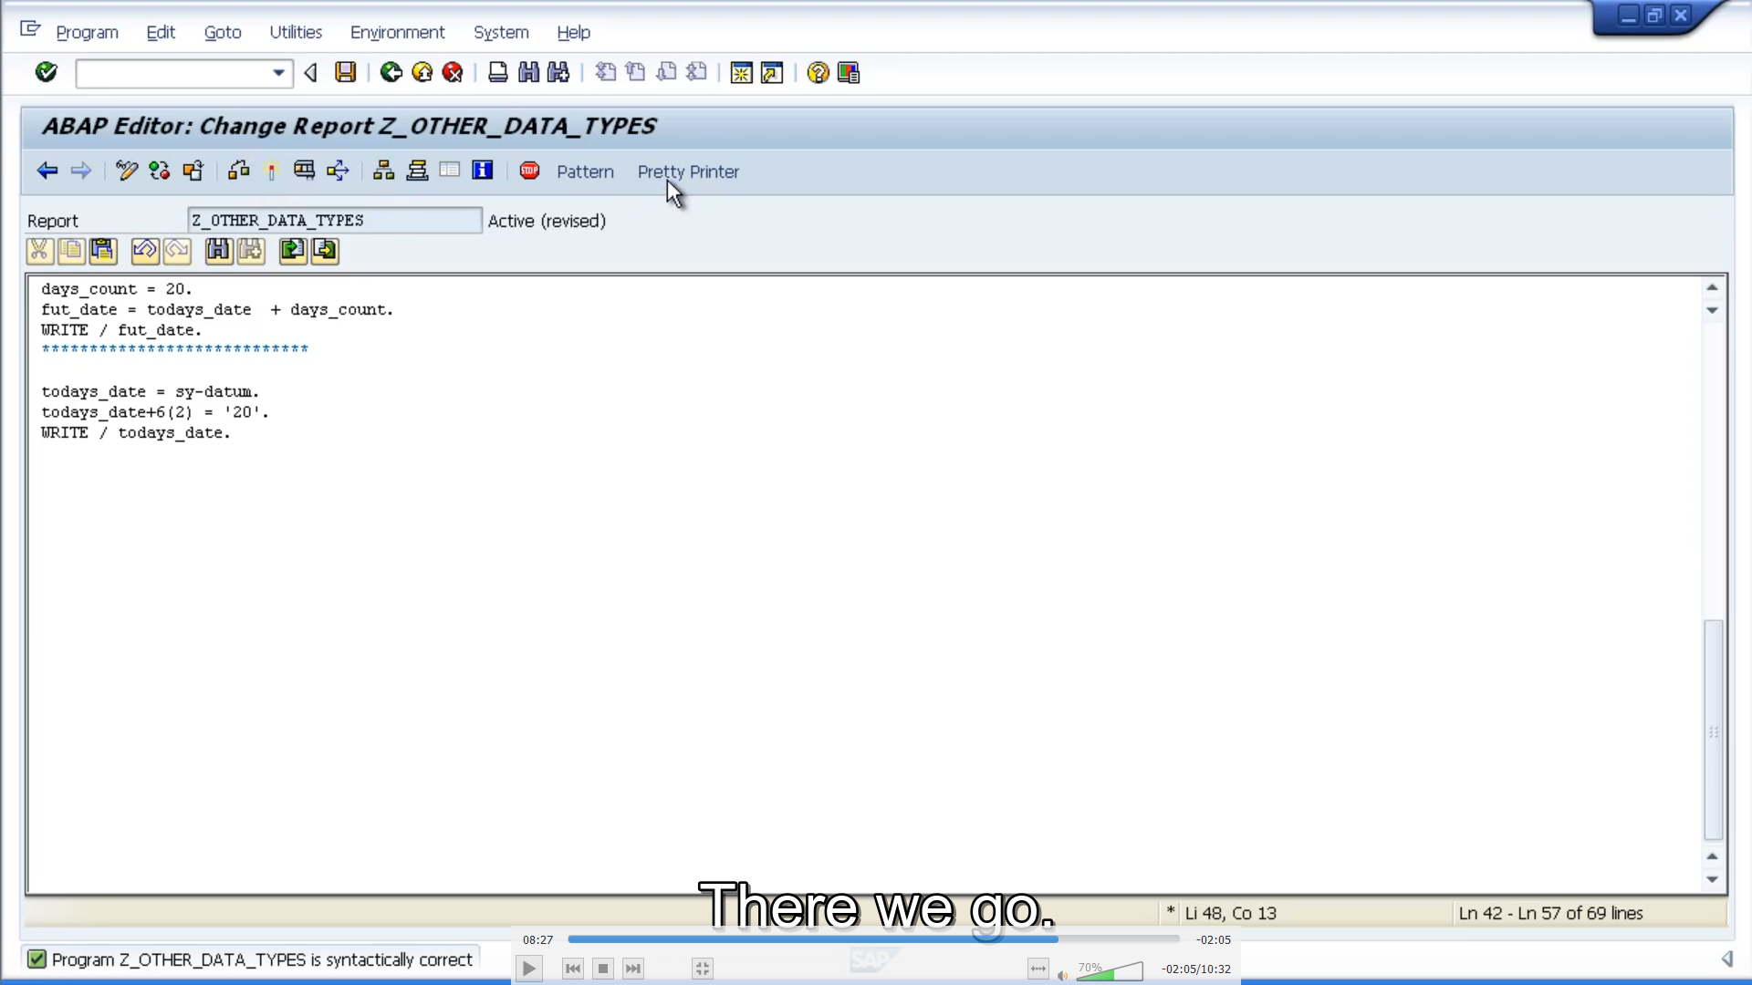

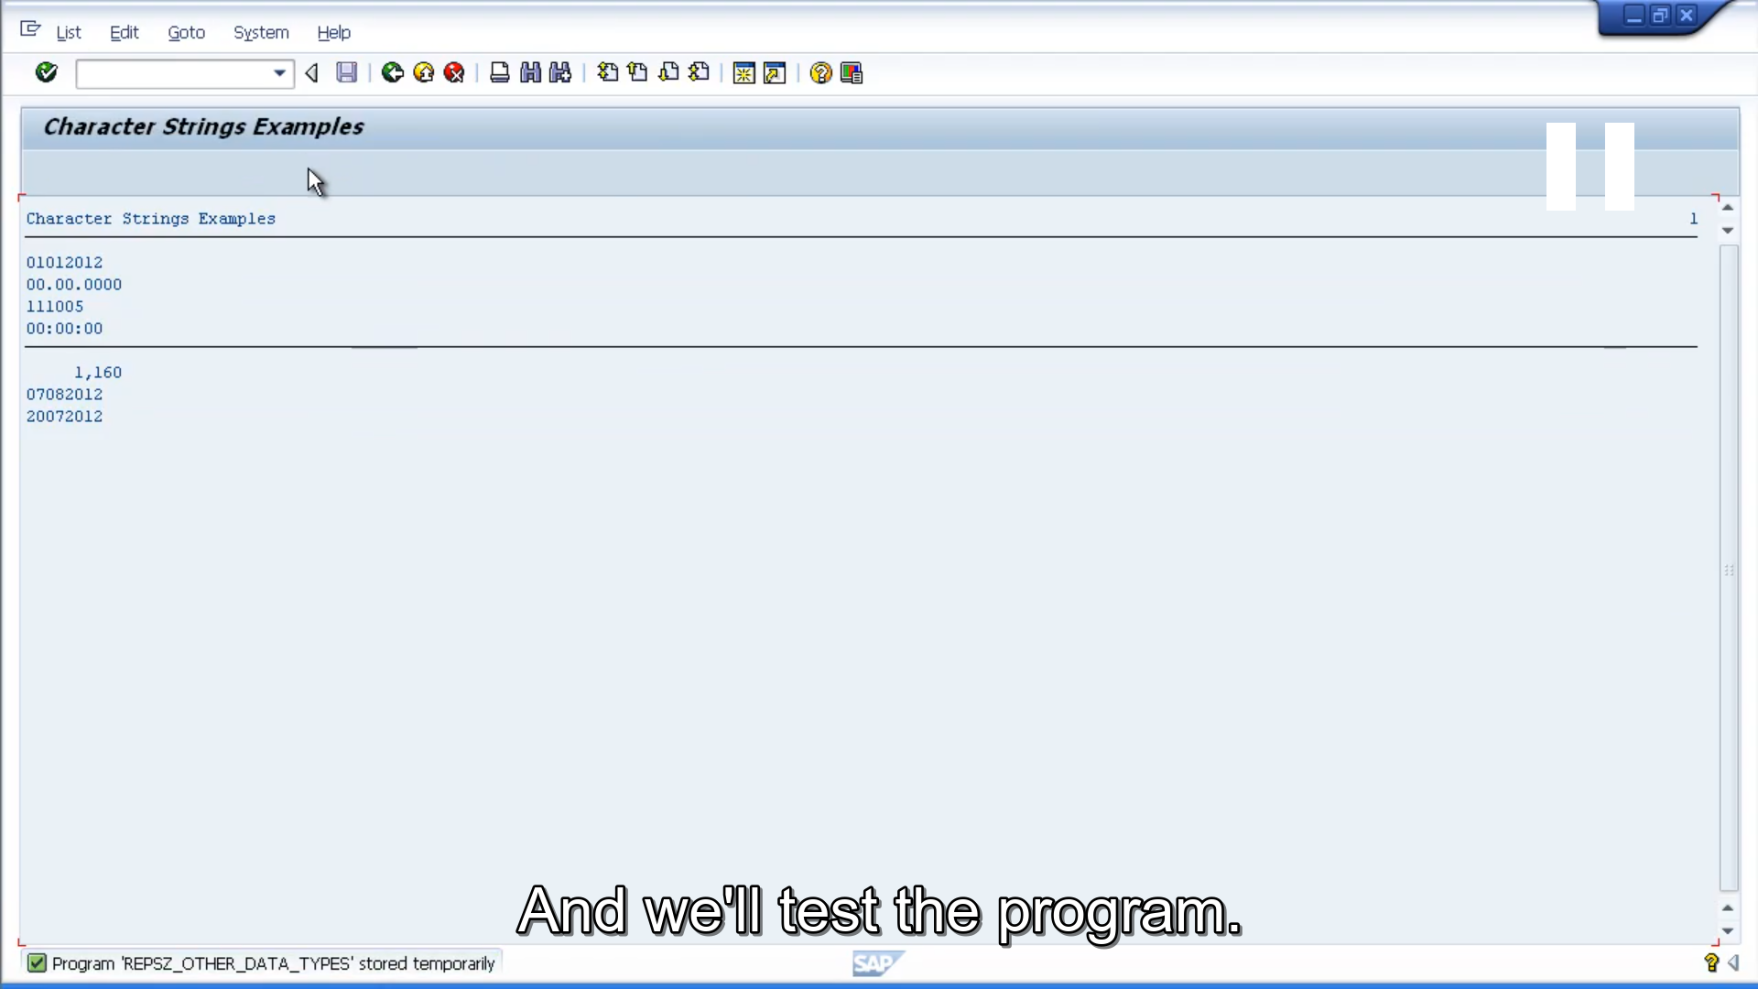

And as you can see, the output now says the 20 July, 2012.

Now in our last example, we will show how we can determine the last day of the previous month. and what we're going to do, is set the day to the first. Then we're going to show how we can subtract a value from today's date.

